Digital Address Book

Project Title: Digital Address Book System
Student Name: Arul Kumar P
Register Number: 921724115006
Department: Computer Science and Design
College Name: Sethu Institute of Technology
Course: Programming in C
Guide/Trainer Name: Balaji B
Submission Date: 26/02/2026

1. Abstract
The Digital Address Book System is a C-based application designed to manage personal contact information efficiently. It solves the problem of manual record-keeping by allowing users to store names, phone numbers, emails, and addresses digitally. The program uses file handling to ensure that data is permanently saved and retrieved even after the program is closed.

2. Introduction
- Problem Solving: This project eliminates the risk of losing physical contact lists and provides a searchable interface for finding information quickly.
- Usefulness: It offers automated data management, allowing users to add, view, search, and delete records with a few keystrokes.
- Usage: It can be used as a personal desktop organizer, a basic CRM for small businesses, or an academic tool for learning data structures.

3. Objectives
- Understand and implement structured programming using C structures.
- Utilize loops and conditional statements for menu navigation and data processing.
- Work with arrays of structures and modular functions to manage data.
- Improve logical thinking by implementing search and delete algorithms.

4. Tools & Technology
- Programming Language: C
- Compiler: GCC / CodeBlocks / Turbo C
- Platform: Windows / Linux

5. System Requirements
- Hardware: A basic computer with at least 4GB RAM to ensure smooth IDE performance.
- Software: Any C compiler (like GCC) and a text editor or IDE (like CodeBlocks or VS Code).

6. Methodology / Algorithm
- Start program and load existing data from addressbook.txt.
- Display menu with options: Add, View, Search, Delete, and Exit.
- Read user input to determine the desired operation.
- Process logic:
  - If Add, take input and save to file.
  - If Search/Delete, compare input strings with stored names.
- Display output showing the results of the operation.
- End program when the user selects the exit option.

- Flowchart

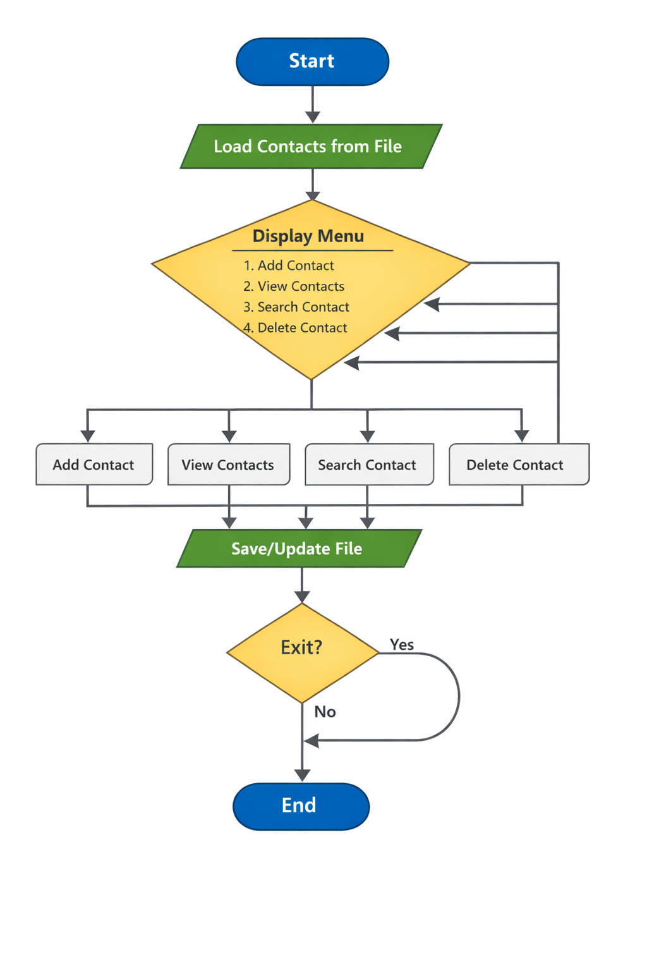

8. Program Code
#include <stdio.h>
#include <stdlib.h>
#include <string.h>

#define MAX 100

struct Contact {
char name[50];
char phone[15];
char email[50];
char address[100];
};

struct Contact contacts[MAX];
int count = 0;

// Function to load contacts from file
void loadFromFile() {
FILE *fp = fopen("addressbook.txt", "r");
if (fp == NULL) return;

while (fread(&contacts[count], sizeof(struct Contact), 1, fp)) {
count++;
}
fclose(fp);
}

// Function to save contacts to file
void saveToFile() {
FILE *fp = fopen("addressbook.txt", "w");
if (fp == NULL) {
printf("Error saving file!\n");
return;
}

fwrite(contacts, sizeof(struct Contact), count, fp);
fclose(fp);
}

// Add new contact
void addContact() {
if (count >= MAX) {
printf("Address book is full!\n");
return;
}

printf("Enter Name: ");
scanf(" %[^\n]", contacts[count].name);

printf("Enter Phone: ");
scanf(" %[^\n]", contacts[count].phone);

printf("Enter Email: ");
scanf(" %[^\n]", contacts[count].email);

printf("Enter Address: ");
scanf(" %[^\n]", contacts[count].address);

count++;
saveToFile();
printf("Contact added successfully!\n");
}

// View all contacts
void viewContacts() {
if (count == 0) {
printf("No contacts found!\n");
return;
}

for (int i = 0; i < count; i++) {
printf("\nContact %d\n", i + 1);
printf("Name: %s\n", contacts[i].name);
printf("Phone: %s\n", contacts[i].phone);
printf("Email: %s\n", contacts[i].email);
printf("Address: %s\n", contacts[i].address);
}
}

// Search contact by name
void searchContact() {
char searchName[50];
int found = 0;

printf("Enter name to search: ");
scanf(" %[^\n]", searchName);

for (int i = 0; i < count; i++) {
if (strcmp(contacts[i].name, searchName) == 0) {
printf("\nContact Found:\n");
printf("Name: %s\n", contacts[i].name);
printf("Phone: %s\n", contacts[i].phone);
printf("Email: %s\n", contacts[i].email);
printf("Address: %s\n", contacts[i].address);
found = 1;
}
}

if (!found)
printf("Contact not found!\n");
}

// Delete contact
void deleteContact() {
char deleteName[50];
int found = 0;

printf("Enter name to delete: ");
scanf(" %[^\n]", deleteName);

for (int i = 0; i < count; i++) {
if (strcmp(contacts[i].name, deleteName) == 0) {
for (int j = i; j < count - 1; j++) {
contacts[j] = contacts[j + 1];
}
count--;
saveToFile();
printf("Contact deleted successfully!\n");
found = 1;
break;
}
}

if (!found)
printf("Contact not found!\n");
}

// Main function
int main() {
int choice;

loadFromFile();

do {
printf("\n==== Digital Address Book ====\n");
printf("1. Add Contact\n");
printf("2. View Contacts\n");
printf("3. Search Contact\n");
printf("4. Delete Contact\n");
printf("5. Exit\n");
printf("Enter your choice: ");
scanf("%d", &choice);

switch (choice) {
case 1: addContact(); break;
case 2: viewContacts(); break;
case 3: searchContact(); break;
case 4: deleteContact(); break;
case 5: printf("Exiting...\n"); break;
default: printf("Invalid choice!\n");
}

} while (choice != 5);

return 0;
}

9. Sample Input / Output
==== Digital Address Book ====
1. Add Contact
2. View Contacts
3. Search Contact
4. Delete Contact
5. Exit
Enter your choice: 1

Enter Name : Sethu
Enter Phone : 9876543210
Enter Email : sethu@gmail.com
Enter Address: Kariyapatti

Contact added successfully!

==== Digital Address Book ====
Enter your choice: 2

Contact 1
----------------------------
Name : Sethu
Phone : 9876543210
Email : sethu@gmail.com
Address : Kariyapatti

==== Digital Address Book ====
Enter your choice: 3

Enter name to search: Sethu

Contact Found:
----------------------------
Name : Sethu
Phone : 9876543210
Email : sethu@gmail.com
Address : Kariyapatti

==== Digital Address Book ====
Enter your choice: 4

Enter name to delete: Sethu

Contact deleted successfully!

==== Digital Address Book ====
Enter your choice: 5

Exiting...

10. Result
The program executed successfully, performing all CRUD (Create, Read, Update, Delete) operations and maintaining data persistence via file handling.

11. Applications
- Learning: Practical application of file I/O and structures in C.
- Academic: Suitable for mini-projects and lab assignments.
- Development: Acts as a foundation for building more complex database management systems.

12. Conclusion
The project successfully demonstrates fundamental C programming concepts, including data persistence, structure arrays, and modular function design.

13. Future Enhancements
- Security: Add a password-protected login system.
- Sorting: Implement an algorithm to sort contacts alphabetically.
- UI: Develop a Graphical User Interface (GUI) instead of a console-based menu.

14. References
- C Programming: A Modern Approach by K.N. King.
- Online Documentation (GeeksforGeeks, Tutorialspoint).
- Classroom Lecture Notes on File Handling.

